**LAB 10 MANUAL**

**Objective**

To create a University Fee Billing System that automatically updates a student's monthly bill whenever a new fee-based course enrollment or activity is recorded.

## Scenario

Each time a student enrolls in a course or participates in a billable activity, the system should:

* Record the fee-related details (student ID, course/activity, date, fee).
* Automatically update the student’s fee bill for that month — inserting a new bill if none exists, or updating an existing one.

**Step 1:** Create Fee Record Table

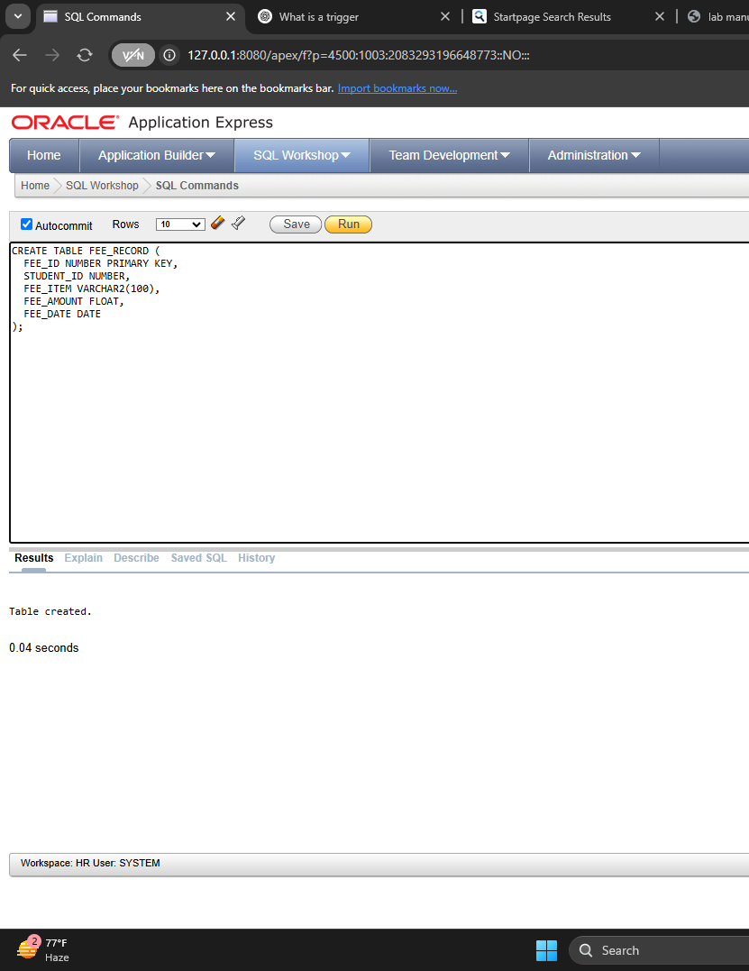

**Step 2:** Create Monthly Billing Table

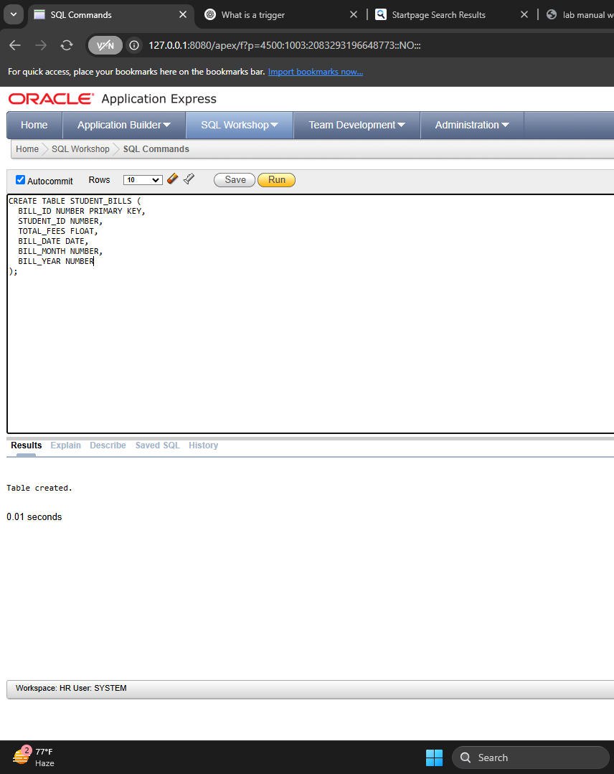

**Step 3:** Create Sequence for BILL_ID

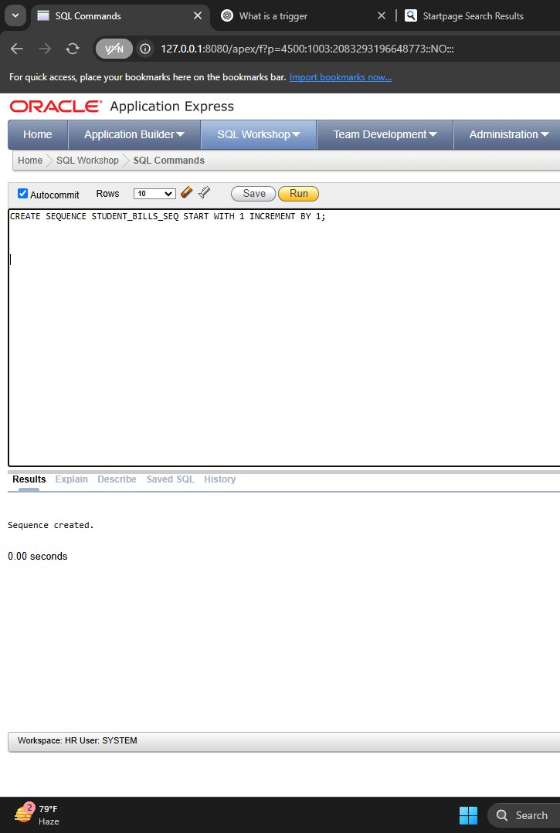

**Step 4:** Trigger to Set BILL_MONTH and BILL_YEAR

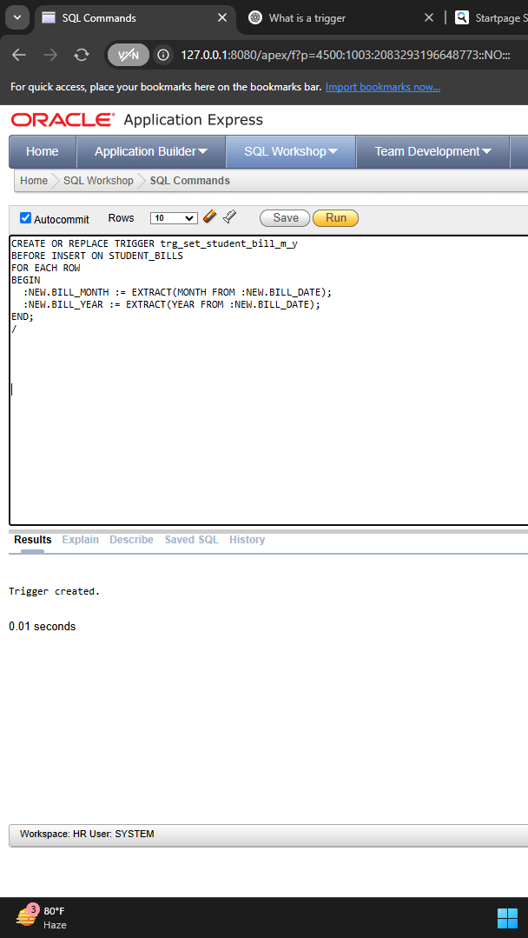

**Step 5:** Trigger to Process Billing on New FEE_RECORD Insert

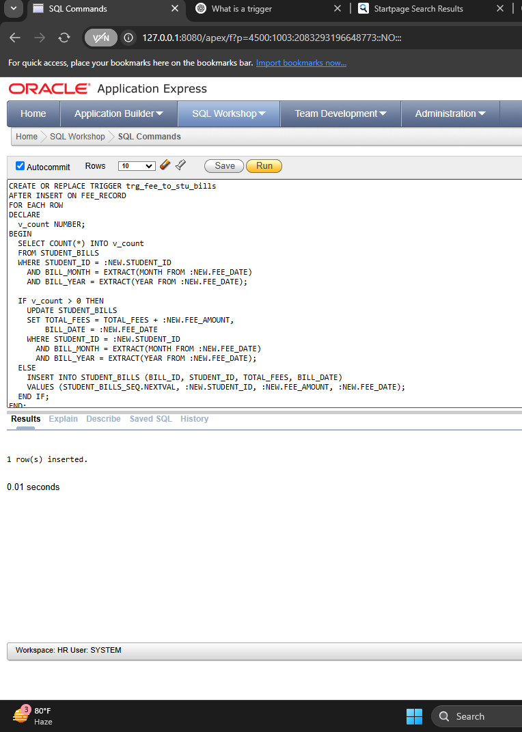

**Step 6:** Insert Fee Records (Test the System)

**Inseration 1:**

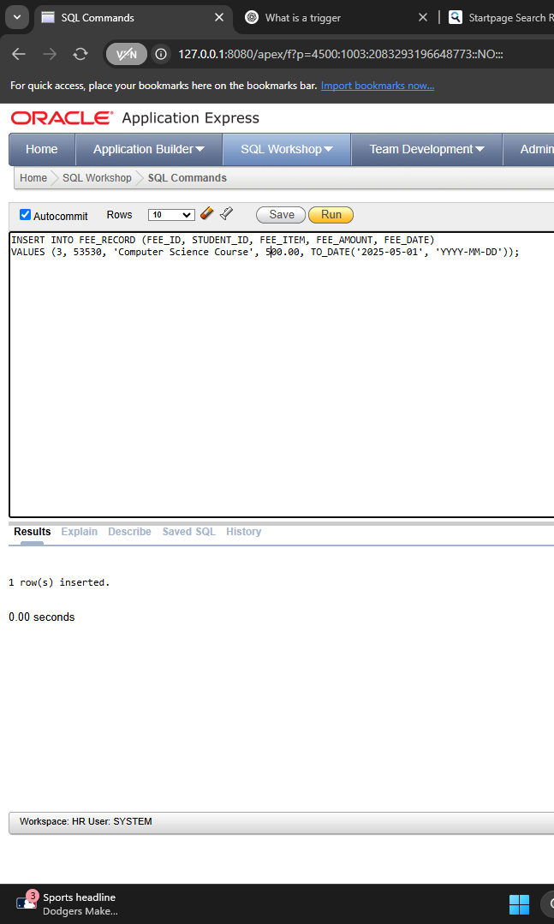

**Insration 2:**

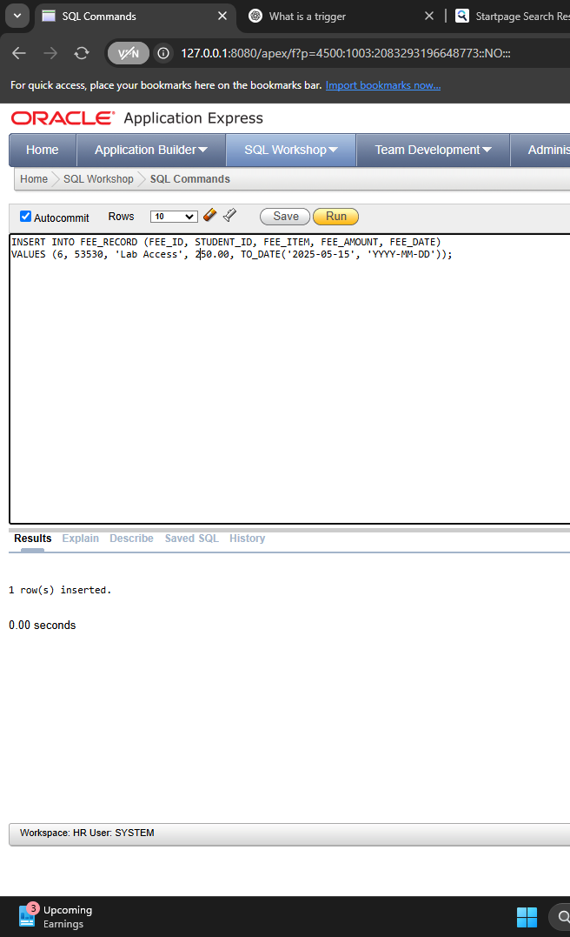

**Step 7:** View Billing Information

